

**Mce Inc Documentation :**

**ISI Interpolation Plugin**

**Mamadou Cisse**

What is it?

A solution to interpolate the value of some data type between two values.

What’s in the Package?

**MceInc.dll:** The dll file which contains some a part of [Mce Inc Engine](http://www.mceinc-engine.com.s3-website.eu-west-2.amazonaws.com/html/namespace_mce_inc_engine_1_1_resource_management.html) and the main code of the interpolation system.

**ISIAnimatorInspector.cs:** The inspector script of ISI Animator class.

**Interpolation Folder:** Contains some components which you can use to access to Mce Inc Extension methods in Unity Inspector without coding like “Transform.DOMove”.

Getting Stated

The interpolation system is like dotween plugin, it allows you to interpolate some data types (specified in Mce Inc documentation).

There are 2 plugins that allows you to use this interpolation system on Unity inspector without coding:

**1 – ISI Animator**

To use this plugin, you must add the component ISI Animator to a Game Object.

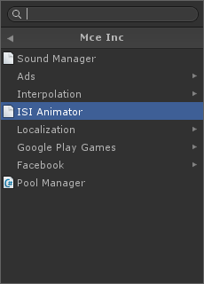

Click on the help button to display a help for each parameter of the plugin in the inspector panel. In the current version, the help is available on two languages, go to the tab “Tools/Mce Inc./Localization/ Editor Language” to choose your language.



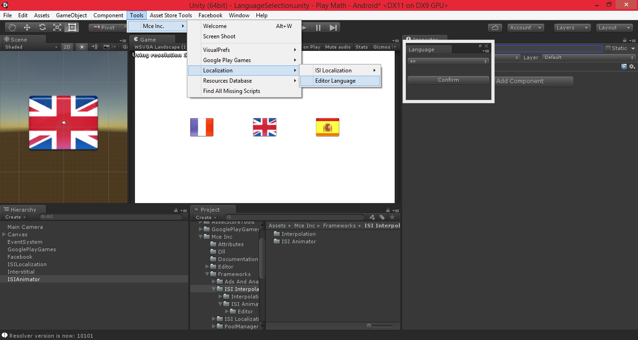



**2 – Interpolation Components:**

This one is just a collection of components that provides you access to Mce Inc Interpolation extension methods thanks to the reflection.

Example for the extension methods of Transform class:

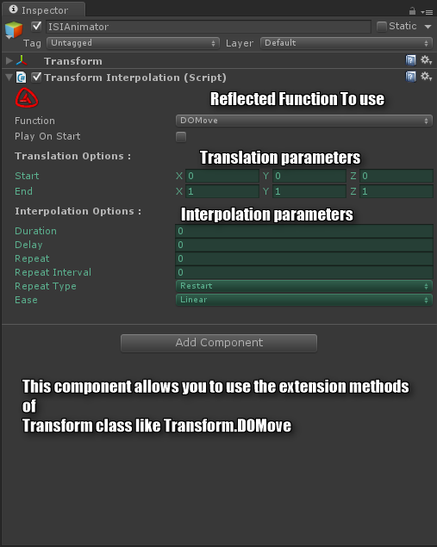

Thanks for your purchase, [please rate this asset](http://u3d.as/GRf) if you like it and consult [my asset store page](https://www.assetstore.unity3d.com/en/#!/search/page=1/sortby=popularity/query=publisher:20627) to see more assets from Mce Inc.

If you have any question, feel free contact me at:

* Mail => [mciissee@gmail.com](mailto:mciisse@gmail.com?subject=AssetStore%20VisualPrefs)
* Twitter => <http://www.twitter.com/IncMce>
* Facebook => <http://www.facebook.com/mceinc>
* Web-Site => <http://mciissee.wixsite.com/mceinc>

.

Good luck for your projects.